Introduction to AWS Identity and Access Management (IAM)

**Lab Overview**

**AWS Identity and Access Management (IAM)** is a web service that enables Amazon Web Services (AWS) customers to manage users and user permissions in AWS. With IAM, you can centrally manage **users**, **security credentials** such as access keys, and **permissions** that control which AWS resources users can access.

**Topics covered**

This lab will demonstrate:

* Exploring pre-created **IAM Users and Groups**
* Inspecting **IAM policies** as applied to the pre-created groups
* Following a **real-world scenario**, adding users to groups with specific capabilities enabled
* Locating and using the **IAM sign-in URL**
* **Experimenting** with the effects of policies on service access

**Other AWS Services**

During this lab, you may receive error messages when performing actions beyond the steps in this lab guide. These messages will not impact your ability to complete the lab.

**AWS Identity and Access Management**

AWS Identity and Access Management (IAM) can be used to:

* **Manage IAM Users and their access:** You can create Users and assign them individual security credentials (access keys, passwords, and multi-factor authentication devices). You can manage permissions to control which operations a User can perform.
* **Manage IAM Roles and their permissions:** An IAM Role is similar to a User, in that it is an AWS identity with permission policies that determine what the identity can and cannot do in AWS. However, instead of being uniquely associated with one person, a Role is intended to be *assumable* by anyone who needs it.
* **Manage federated users and their permissions:** You can enable *identity federation* to allow existing users in your enterprise to access the AWS Management Console, to call AWS APIs and to access resources, without the need to create an IAM User for each identity.

**Start Lab**

**Creating IAM Users**

1. In the **AWS Management Console**, on the **Services** menu, click **IAM**.
2. In the navigation pane on the left, click **Users**
3. Click **Add user**

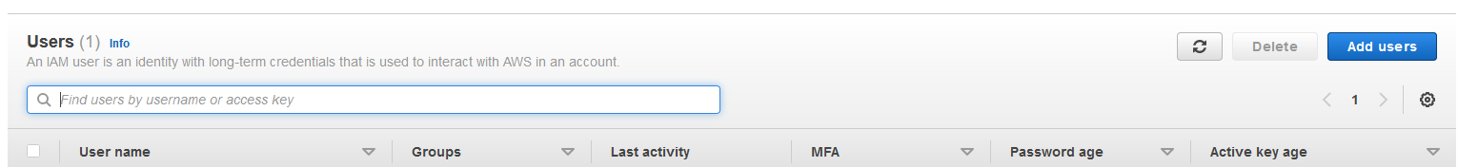

1. **User Name:** user-1
2. Select **Enable console access**

1. For **Console password,** select **Autogenerated password**
2. Dissect **Users must create a new password at next sign-in**
3. Click **Next**

1. Click **Next**
2. Click **Next**
3. Click **Create user**
4. Finally, download the csv file to your computer containing user credentials.

1. Repeat above steps for **user-2** and **user-3**

**Creating IAM Groups**

1. In the navigation pane on the left, click **User** **Groups**
2. Let’s create 3 user groups
   1. EC2-Admin
   2. EC2-Support
   3. S3-Support
3. To create the first group,
4. Click **Create Group**

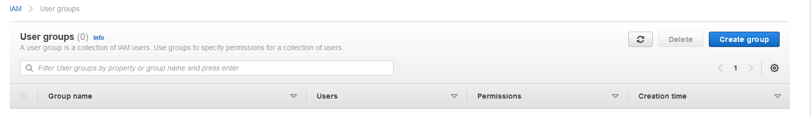

1. **User Group Name:** EC2-Admin
2. Scroll down to the bottom of the page and click **Create Group**



We need to setup inline policy for **EC2-Admin** Group

1. Navigate to the newly created **EC2-Admin** Group and click on it
2. Select **Permission** tab

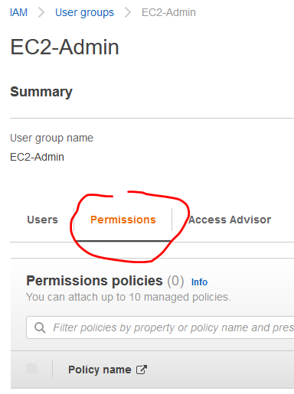

1. Click on **Add Permission**

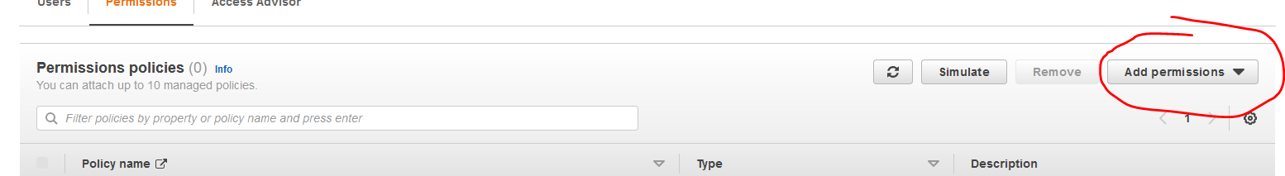

1. Select **Create inline Policy**
2. Click on Json
3. Paste the below policy **in Policy Document**

|  |
| --- |
| {  "Version": "2012-10-17",  "Statement": [  {  "Effect": "Allow",  "Action": [  "Ec2:StopInstances",  "Ec2:DescribeInstances",  "Ec2:StartInstances"  ],  "Resource": [  "*"  ]  }  ]  } |

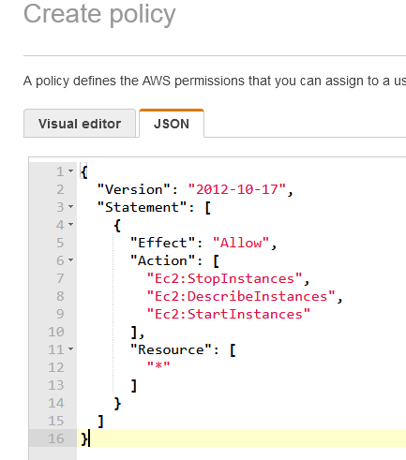

1. Click **Review policy**
2. **Name: Ec2-Inline_Policy**
3. Click **Create policy**
4. To create the second Group,
5. Click **Create Group**
6. **Group Name** EC2-Suppot
7. Under **Attach permissions policy** in the search bar**,** type **AmazonEC2ReadOnlyAccess**
8. Press **Enter**
9. Select **AmazonEC2ReadOnlyAccess**
10. Click **Create Group**
11. To create the third Group,
12. Click **Create New Group**
13. **Group Name** S3-Support
14. Under **Attach permissions policy** in the search bar**,** type **AmazonS3ReadOnlyAccess**
15. Press **Enter**
16. Select **AmazonS3ReadOnlyAccess**
17. Click **Create Group**

**Task 1: Explore the Users and Groups**

In this task, you will explore the Users and Groups that you just been created in IAM.

1. In the **AWS Management Console**, on the **Services** menu, click **IAM**.
2. In the navigation pane on the left, click **Users**.

View the following IAM Users that you created:

* user-1
* user-2
* user-3

1. Click **user-1**.

This will bring to a summary page for user-1. The **Permissions** tab will be displayed.

1. Notice that user-1 does not have any permissions.
2. Click the **Groups** tab.

user-1 also is not a member of any groups.

1. Click the **Security credentials** tab.

user-1 is assigned a **Console password**

1. In the navigation pane on the left, click **Groups**.

View the following groups that you already created:

* EC2-Admin
* EC2-Support
* S3-Support

1. Click the **EC2-Support** group.

This will bring you to the summary page for the **EC2-Support** group.

1. Click the **Permissions** tab.

This group has a Managed Policy associated with it, called **AmazonEC2ReadOnlyAccess**. Managed Policies are pre-built policies (built either by AWS or by your administrators) that can be attached to IAM Users and Groups. When the policy is updated, the changes to the policy are immediately apply against all Users and Groups that are attached to the policy.

1. Click the plus icon next to **AmazonEC2ReadOnlyAccess** to show Policy

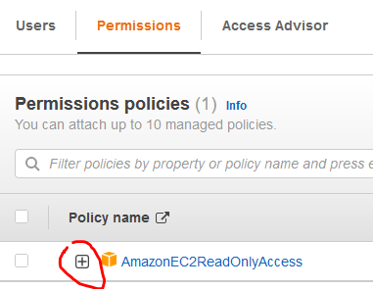

A policy defines what actions are allowed or denied for specific AWS resources. This policy is granting permission to List and Describe information about EC2, Elastic Load Balancing, CloudWatch and Auto Scaling. This ability to view resources, but not modify them, is ideal for assigning to a Support role.

The basic structure of the statements in an IAM Policy is:

* **Effect** says whether to *Allow* or *Deny* the permissions.
* **Action** specifies the API calls that can be made against an AWS Service (eg *cloudwatch:ListMetrics*).
* **Resource** defines the scope of entities covered by the policy rule (eg a specific Amazon S3 bucket or Amazon EC2 instance, or * which means *any resource*).

1. Close the **Show Policy** window.
2. In the navigation pane on the left, click **Groups**.
3. Click the **S3-Support** group.

The S3-Support group has the **AmazonS3ReadOnlyAccess** policy attached.

1. Click the plus icon next to **AmazonS3ReadOnlyAccess** to show Policy

This policy has permissions to Get and List resources in Amazon S3.

1. In the navigation pane on the left, click **Groups**.
2. Click the **EC2-Admin** group.

This Group is slightly different from the other two. Instead of a *Managed Policy*, it has an **Inline Policy**, which is a policy assigned to just one User or Group. Inline Policies are typically used to apply permissions for one-off situations.

1. Under **Actions**, click **Edit Policy** to view the policy.

This policy grants permission to view (Describe) information about Amazon EC2 and also the ability to Start and Stop instances.

1. At the bottom of the screen, click **Cancel** to close the policy.

**Business Scenario**

For the remainder of this lab, you will work with these Users and Groups to enable permissions supporting the following business scenario:

Your company is growing its use of Amazon Web Services, and is using many Amazon EC2 instances and a great deal of Amazon S3 storage. You wish to give access to new staff depending upon their job function:

|  |  |  |
| --- | --- | --- |
| **User** | **In Group** | **Permissions** |
| user-1 | S3-Support | Read-Only access to Amazon S3 |
| user-2 | EC2-Support | Read-Only access to Amazon EC2 |
| user-3 | EC2-Admin | View, Start and Stop Amazon EC2 instances |

**Task 2: Add Users to Groups**

You have recently hired **user-1** into a role where they will provide support for Amazon S3. You will add them to the **S3-Support** group so that they inherit the necessary permissions via the attached *AmazonS3ReadOnlyAccess* policy.

Add user-1 to the S3-Support Group

1. In the left navigation pane, click **Groups**.
2. Click the **S3-Support** group.
3. Click the **Users** tab.
4. In the **Users** tab, click **Add Users**.

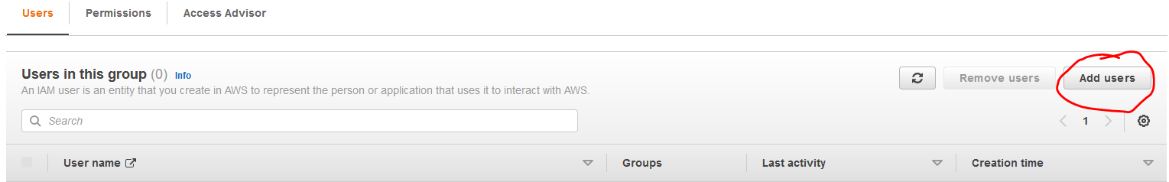

1. In the **Add Users to S3-Support** window, configure the following:

* Select  **user-1**.
* At the bottom of the screen, click **Add Users**.

 In the **Users** tab you will see that **user-1** has been added to the group.

Add user-2 to the EC2-Support Group

 You have hired **user-2** into a role where they will provide support for Amazon EC2.

1. Using similar steps to the ones above, add **user-2** to the **EC2-Support** group.

**user-2** should now be part of the **EC2-Support** group.

Add user-3 to the EC2-Admin Group

 You have hired **user-3** as your Amazon EC2 administrator, who manage your EC2 instances.

1. Using similar steps to the ones above, add **user-3** to the **EC2-Admin** group.

**user-3** should now be part of the **EC2-Admin** group.

1. In the navigation pane on the left, click **Groups**.

Each Group should have a **1** in the Users column for the number of Users in each Group.

If you do not have a **1** beside each group, revisit the above instructions to ensure that each user is assigned to a Group, as shown in the table in the Business Scenario section.

**Task 3: Sign-In and Test Users**

In this task, you will test the permissions of each IAM User.

**\*\* Launch a test server as root before testing**

1. In the navigation pane on the left, click **Dashboard**.

An **IAM users sign-in link** is displayed It will look similar to: *https://123456789012.signin.aws.amazon.com/console*

This link can be used to sign-in to the AWS Account you are currently using.

1. Copy the **IAM users sign-in link** to a text editor.
2. Open a private window.

**Mozilla Firefox**

* Click the menu bars  at the top-right of the screen
* Select **New Private Window**

**Google Chrome**

* Click the ellipsis  at the top-right of the screen
* Click **New incognito window**

**Microsoft Edge**

* Click the ellipsis  at the top-right of the screen
* Click **New InPrivate window**

**Microsoft Internet Explorer**

* Click the **Tools** menu option
* Click **InPrivate Browsing**

1. Paste the **IAM users sign-in** link into your private window and press **Enter**.

You will now sign-in as **user-1**, who has been hired as your Amazon S3 storage support staff.

1. Sign-in with:

* **IAM user name:** 
* **Password:** Paste the value of *user-1 password*

1. In the **Services** menu, click **S3**.
2. Click the bucket that has **s3bucket** in its name.

Since your user is part of the **S3-Support** Group in IAM, they have permission to view a list of Amazon S3 buckets and the contents of the **s3bucket**.

Now, test whether they have access to Amazon EC2.

1. In the **Services** menu, click **EC2**.
2. Navigate to the region that your lab was launched in by:

* Clicking the drop-down  arrow at the top of the screen, to the left of **Support**
* Selecting the region value that matches the value of **Region** to the left of these instructions

1. In the left navigation pane, click **Instances**.

You cannot see any instances. This is because your user has not been assigned any permissions to use Amazon EC2.

You will now sign-in as **user-2**, who has been hired as your Amazon EC2 support person.

1. Sign user-1 out of the **AWS Management Console** by configuring the following:

* At the top of the screen, click **user-1**
* Click **Sign Out**

1. Paste the **IAM users sign-in** link into your private window and press **Enter**.

This links should be in your text editor.

1. Sign-in with:

* **IAM user name:** 
* **Password:** Paste the value of *user-2*

1. In the **Services** menu, click **EC2**.

 At the top right of the screen, enable **New EC2 Experience** by toggling the button, if it is not enabled by default.

1. Navigate to the region that your lab was launched in by:

* Clicking the drop-down  arrow at the top of the screen, to the left of **Support**
* Selecting the region value that matches the value of **Region** to the left of these instructions

1. In the navigation pane on the left, click **Instances**.

You are now able to see an Amazon EC2 instance because you have Read Only permissions. However, you will not be able to make any changes to Amazon EC2 resources.

Your EC2 instance should be selected  If it is not selected, select  it.

1. In **Instance state**, menu click **Stop instance**.
2. In the **Stop instance** window, click **Stop**.

 You will receive an error stating *You are not authorized to perform this operation*. This demonstrates that the policy only allows you to information, without making changes.

1. Close the displayed error message.

* Next, check if user-2 can access Amazon S3.

1. In the **Services**, click **S3**.

* You will receive an  **Error Access Denied** because user-2 does not permission to use Amazon S3.

1. You will now sign-in as **user-3**, who has been hired as your Amazon EC2 administrator.

* Sign user-2 out of the **AWS Management Console** by configuring the following:
* At the top of the screen, click **user-2**
* Click **Sign Out**

1. Paste the **IAM users sign-in** link into your private window and press **Enter**.
2. Paste the sign-in link into your web browser address bar again. If it is not in your clipboard, retrieve it from the text editor where you stored it earlier.
3. Sign-in with:

* **IAM user name:** 
* **Password:** Paste the value of *AdministratorPassword* located to the left of these instructions.

1. In the **Services** menu, click **EC2**.
2. Navigate to the region that your lab was launched in by:

* Clicking the drop-down  arrow at the top of the screen, to the left of **Support**
* Selecting the region value that matches the value of **Region** to the left of these instructions

1. In the navigation pane on the left, click **Instances**.

* As an EC2 Administrator, you should now have permissions to Stop the Amazon EC2 instance.
* Your EC2 instance should be selected . If it is not, please select  it.

1. In **Instance state**, menu click **Stop instance**.
2. In the **Stop Instance** window, click **Stop**.

* The instance will enter the *stopping* state and will shutdown.

**Conclusion**

 Congratulations! You now have successfully:

* Explored pre-created IAM users and groups
* Inspected IAM policies as applied to the pre-created groups
* Followed a real-world scenario, adding users to groups with specific capabilities enabled
* Located and used the IAM sign-in URL
* Experimented with the effects of policies on service access